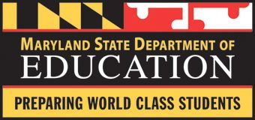
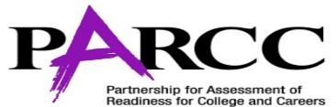

Are You Interested in Learning More about the Maryland College & Career Readiness Standards and PARCC Assessment?

If so, the Maryland State Department of Education has a wealth of resources for parents regarding the Maryland College & Career Readiness Standards (formerly Maryland Common Core Standards) and PARCC (Partnership for Assessment of Readiness for College and Careers) assessment. Resources include:

MCCRS
- The MSDE Website: www.marylandpublicschools.org
  - Click on Maryland College & Career Readiness Standards under “Popular Searches”
- www.mdk12.org
  - Click on Teaching & Learning or MCCR Frameworks
- The PARCC Website: www.parcconline.org
  - Click on Parent Resources
    - The Common Core State Standards
- The Maryland PTA: www.mdpta.org
  - Click on Parent & Family Involvement
    - Article: “What Parents Need to Know about the Common Core State Curriculum”
    - Article: “Maryland’s New Common Core State Standards
PARCC
- The MSDE Website: www.marylandpublicschools.org
  - Click on the PARCC Icon
  - MSDE Parent Webinars
    - A parent webinar series is beginning January 20, 2015. All webinars will be held live, recorded and posted.
    - Webinar topics include:
      - PARCC Assessments: Structure & Thinking Skills (Learn about the design of the PARCC assessments, explore available resources, and uncover the thinking skills measured on the assessments.)
      - Social Studies and Disciplinary Literacy (2 coming)
      - Instructional Technology Parent Resources on Blackboard
      - Instructional Technology Student Online Resources
      - Mathematics: Understanding the PARCC Timeline & Resources for Parents
- www.mdk12.org
  - Click on PARCC
- The PARCC Website: www.parcconline.org
  - Click on Parent Resources
    - Frequently Asked Questions
    - PARCC Fact Sheet
    - PARCC Overview
    - A Parent’s Guide
    - Sample Test Items
    - PARCC Accessibility Features and Accommodations Manual (For English Language Learners and Students with Disabilities)
- The Maryland PTA: www.mdpta.org
  - Click on Parent & Family Involvement
    - Article: “The Road Ahead: The PARCC Assessments”
- Click on The Top 10 Things Parents Need to Know about Testing in Maryland

